**Users / Role:**

1. **Admin**
2. **Exam in charge**
3. **Exam staff**

**Description: Exam addition under different categories**

|  |  |  |  |
| --- | --- | --- | --- |
| Sl No | Activity | User | Remarks |
|  | Create New exams | Admin, exam staff |  |
| Ex-1 | Add exam category to new exams | Admin, exam staff |  |
| Ex-2 | Provide category code to newly allotted exams | Admin, Exam Staff |  |
| Ex-3 | Edit/View created exams | Admin, Exam Staff |  |
| Ex-4 | Delete created exams | Admin, Exam Staff |  |
| Ex-5 | Search exam dropdown | Admin, Exam Staff |  |
| Ex-6 | Browse through created exams | Admin, Exam Staff |  |

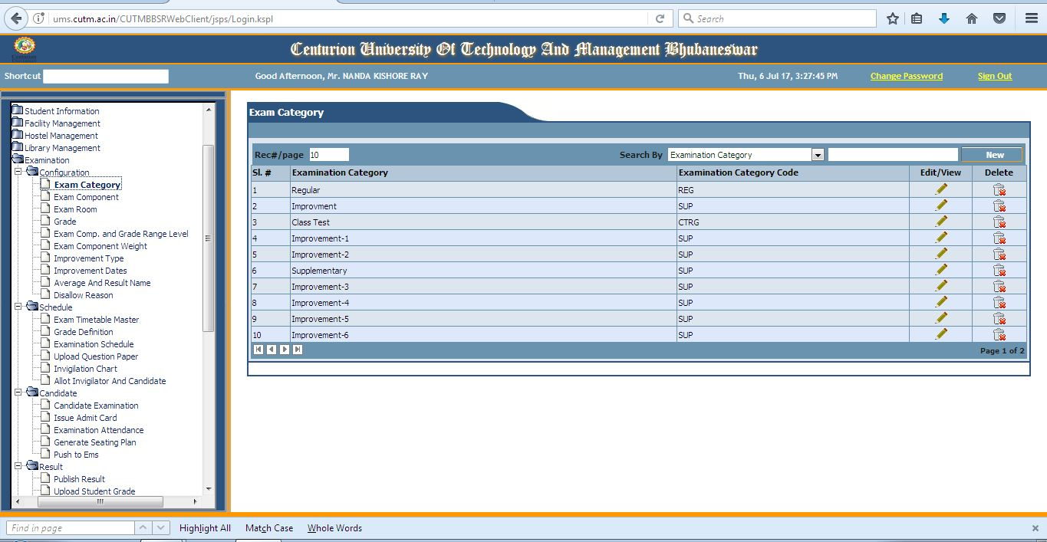

* **In this page of exam category categories of exam will be dealt with.**
* **New categories can be created.**
* **Created categories can be viewed here.**
* **Manipulation of categories will be done here such as creation of new categories with respective category codes.**
* **Categories can be deleted here for no longer use.**
* **Searching of created categories can be done with precision.**